# [Mariska Hargitay teases the return of ‘Law & Order’ in playful pic with Chris Meloni](https://www.today.com/popculture/tv/mariska-hargitay-posts-new-pic-chris-meloni-law-order-set-rcna39869?cid=sm_npd_td_tw_ma)

Just kiss already!

July 25, 2022, 3:11 PM -03 / Source: TODAY

By MC Suhocki

The "Law & Order" franchise returns in 59 days (we're counting so you don't have to), and ["Law & Order: SVU" star Mariska Hargitay](https://www.today.com/popculture/500th-svu-episode-brings-flashbacks-returning-characters-t235156) just gave fans a glimpse at how filming for the upcoming 24th season is going by sharing a photo with ["Law & Order: Organized Crime" star Chris Meloni](https://www.today.com/popculture/tv/new-pics-mariska-hargitay-chris-meloni-filming-law-order-rcna24378).

"aaannnnd we’re back!" the actor behind prime time's longest-running live-action character [wrote Monday](https://www.instagram.com/p/CgcRB4kg1bK/?hl=en) on her Instagram page along with a photo of [her longtime friend and partner in crime](https://www.today.com/popculture/mariska-hargitay-chris-meloni-birthday-pic-rcna22807), who plays Elliot Stabler in the upcoming third season of "OC."

Hargitay also shared a few of her signature hashtags, including #Bensler, #MarshMelon and #BetweenTakes.

Bensler, of course, is a combination of her character's last name, Benson, and Meloni's character's last name, Stabler.

She elaborated on the meaning behind the Marshmelon nickname (a combination of Marsha and Meloni) during an appearance with Meloni [on "Late Night With Seth Meyers"](https://www.today.com/popculture/tv/mariska-hargitay-chris-meloni-re-create-moment-met-svu-audition-rcna21982) in March.

“Oh, Marshmelon,” Hargitay said at the time. “Chris calls me Marsha sometimes. One of the many names.”

Mariska Hargitay is seen on the set of "Law and Order: Special Victims Unit" on July 20, 2022, in New York City looking flawless in a fitted blazer.Jose Perez / Bauer-Griffin / GC Images

It's been rumored that September's premiere episodes will be a three-part crossover among all three "Law & Order" shows, with "Law & Order" star Jeffrey Donovan teasing a crossover in a photo [he shared on Twitter](https://twitter.com/WickedpissaJD/status/1549855060003364867?s=20&t=-KvIZirk1x1Tpva3kxGlCg) last week, and, of course, Hargitay's photo with Meloni.

"Law & Order" showrunner Rick Eid discussed the possibility of a crossover with all three "L&O" shows in [an interview with TODAY in April](https://www.today.com/popculture/tv/mariska-hargitay-will-appear-law-order-finale-rcna26690).

“That’s something that will probably happen in Season Two," he said. “We’ve definitely been talking about a three-part crossover.”

Many fans, including ourselves, are wondering how things will pick up between [Benson and Stabler](https://www.today.com/popculture/tv/olivia-benson-elliot-stabler-relationship-timeline-law-and-order-svu-rcna37289), given how the season ended for Benson.

The Special Victims Unit captain's therapist encouraged her to explore a romance with Stabler or to move on, adding that "this idealized relationship" with Stabler "is hanging over" her and holds her back from “true intimacy” with her former partner or anyone else. He also reminded Benson that she "deserves happiness."

### *Recommended*



### [TV](https://www.today.com/popculture/tv)[‘Grey’s Anatomy’ mini-reunion! See Sandra Oh’s pic from the Emmys](https://www.today.com/popculture/tv/greys-anatomy-mini-reunion-2022-emmy-awards-rcna47572)



### [TV](https://www.today.com/popculture/tv)[Is Caroline Manzo as Italian as the Olive Garden? Dolores Catania answers](https://www.today.com/popculture/tv/dolores-catania-caroline-manzo-celebrity-beef-rcna47508)

Benson's friend, Amanda Rollins, who’s a detective in her unit, also offered her some advice in the Season 23 finale about Stabler. Rollins shared some words of wisdom her mother once gave her when she was in a similar situation with her now-love interest, A.D.A. Dominick Carisi, and she implied Benson and Stabler could always go to a hotel room to get whatever's been going on between them for all these years out of their systems.

“That’s some advice,” Benson replied.

As for Stabler, he just wrapped up another undercover arc and received the esteemed Combat Cross while discovering that his late father, who was also a cop, once staged a shooting on the job: a shooting that earned his dad a Combat Cross.

On the red carpet at NBCUniversal’s upfront in May, [Meloni told TODAY](https://www.today.com/popculture/tv/chris-meloni-story-law-order-set-pics-mariska-hargitay-rcna29078) that Benson may be struggling more than Stabler with where they stand in their feelings for one another.

“Well, I think, and this is just my perspective, I think now it’s Olivia who’s having more difficulties than Stabler,” he said.

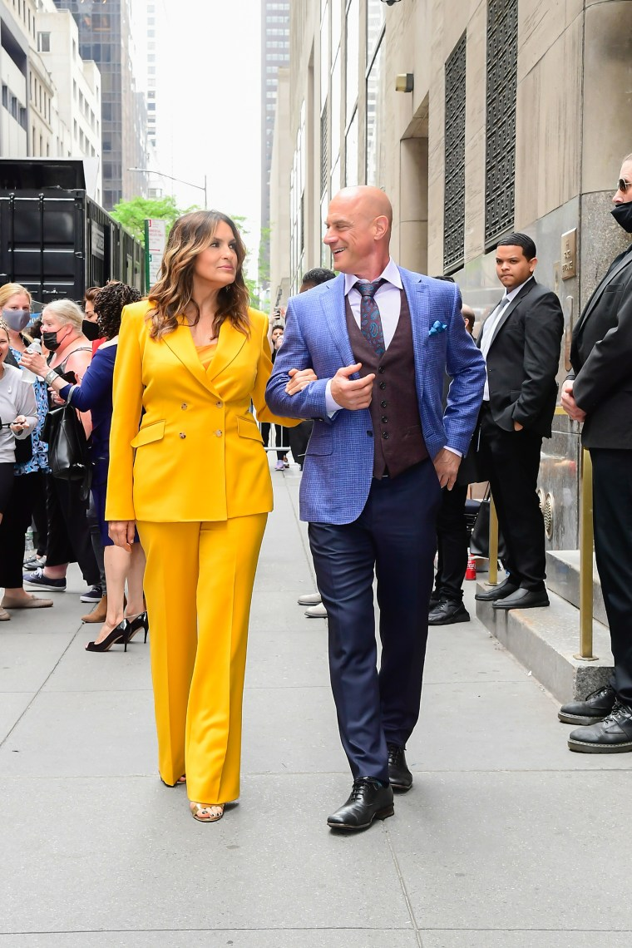Mariska Hargitay and Christopher Meloni sizzle at the 2022 NBCUniversal Upfront on May 16, 2022, in New York City. Raymond Hall / GC Images

“I was reintroduced into this universe having freshly lost my wife and trying to ⁠— coming back to a place and a situation that I hadn’t been in.”

“So I think it’s as the feelings build and the reality builds that, oh, we’re in an environment where we can act on these feelings, possibly, then it’s getting all too real,” he added.

*"Law & Order," "Law & Order: SVU" and "Law & Order: Organized Crime" return Thursday, Sept. 22, at 8 p.m. ET on NBC.*